Car Racing Video Game – Journey

# Purpose

The purpose of these notes is to document my journey in learning how to build a modern car racing video game. I am into the history of things, so I plan on exploring the evolution of car racing games from Grand Prix on the Atari 2600 to Outrun and modern car racing games[1]. My main goal is to build examples of many these car racing games to gain knowledge of the evolution of car racing games, using C++ and auxiliary tools (e.g. Tiled Map Editor).

Unfortunately, I must explore modern C++. Nothing wrong with C++ just that I have not coded in C++ for over a decade (maybe more). I come from a strong C[2] programming background but have been primarily a Java backend developer for the last twenty years. I see that C++ has changed quite a bit with the goal of adding more common data structures (e.g. <vector>) and modern programming concepts to make memory management safer (unique_ptr).

The beginning of this journey will start less with car racing games and more into getting acquainted with C++, SDL2, and many other tools and applications. The more I learn the more I will start to build car racing games as we go through the techniques required to construct everything from Night Driver to Mario Kart to a more modern racing game[3].

I will take two approaches to what I refer to as “Car Racing Video Game” (CRVG) project:

* ***Informal*** – Online tutorials, reading books and creating code all in the journey to learning how to make a game
* ***Formal*** – Any writing and code that directly pertains to CRVG

# Phase 1 – Learning, Learning, Learning

Nobody in this industry knows what they’re doing, we just have a gut assumption based on the games that we can play. – Cliff Bleszinski

Cliff Bleszinski is famous for the ***Unreal Engine*** and ***Gears of War*** while at ***Epic Games***. Many games today are built from the Unreal Engine – ***Fortnight***, ***Black Myth: Wukong***, ***Borderlands 4***, and too many more to list[4]. The first step for me is to relearn C++, libraries and tools used to create video games like SDL2 and Tiled Map Editor.

The initial learning process will involve video tutorials, books and some online website tutorials. I will mention everything I find worthwhile in these notes.

## Following YouTube Tutorials

The first thing I decided to do was to follow some YouTube tutorials that covered building video games with C++ or tools you would want to use in building games. I follow and take individual notes[5] which hopefully provide more details. I look up a lot of information using Copilot and google searches since it is my experience that the video presenter does not cover every term and technique presented. In my notes, I may not provide attribution for all the code, definitions, and explanations but I will try.

I use a combination of sources to learn the same material. I find some courses, for example, any at the Pikuma web site excellent material for learning game development. I encourage you to check it out. The prices are fair and kept up to date.

## How to Make a 2D Game Engine with C++ & SDL2

***Progress:*** 36% completed

This is a YouTube playlist: <https://www.youtube.com/playlist?list=PL-K0viiuJ2RctP5nlJlqmHGeh66-GOZR_> covers the development of a 2D platformer type game using C++ and SDL2.

The video assumes you know C++ rather well and does not get into any language discussions – other than how to build classes in C++ that function as Singletons. The video also uses ***Code::Blocks*** are the IDE. I can understand its selection since it is available on all major operating system platforms. It could be the version of Code::Blocks but if felt like the presenter did not utilize all the cool features of Code::Blocks, for example, he seemed to prefer the Java style of braces but always just manually edited the generated files and functions rather than changing the source code style. I also noticed he always removed the destructor method the code automatically generated rather than just deselecting that option when a new class was created using the wizard for creating a new class:



Figure - Deselecting "Virtual destructor"

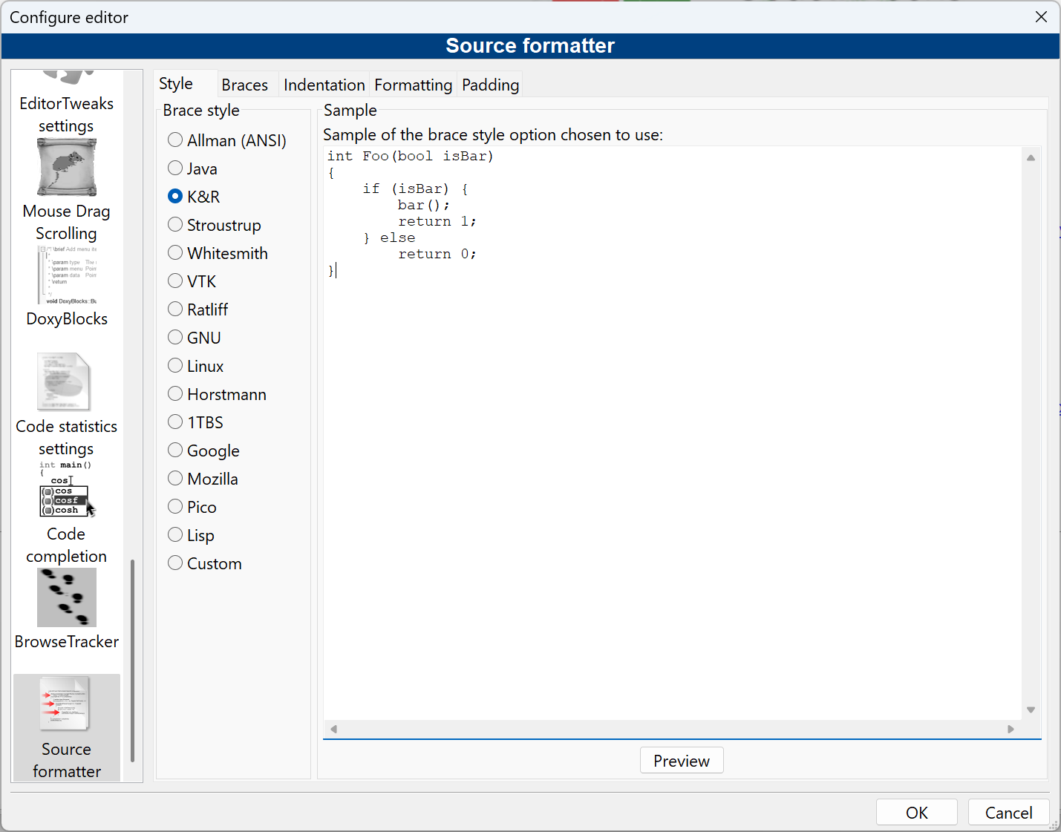

Figure - Selecting the Source Formatter

I also purchased the book written by the video presenter, Franc Poulhela, ***Cross-Platform 2D Game with SDL2***. The book was inspired by making the video series but alas it is completely different. It uses Video Studio Code and is more in the spirit of writing a game engine and then using that game engine to create a Flappy Bird clone game. I decided to put off reading the book until I am done with this series. Like most series the first one had 87K views but by video #39 it drops to 10K and the last one in the playlist is half that number. I think many people dropped off because the game assets after video #7 are not available unless you become a Patreon member.

I did become a Patreon member so I can follow along. I was very proud that in video #17 I fixed the code presented so an ugly kludge was avoid – the off by one the calculation of a row and col counts are if the tile is the last one in the row.

Each video takes me hours to complete because I:

* Make sure I understand everything (no ***code monkey*** here)
* I create diagrams to illustrate the algorithm or concept being presented
* I correct the algorithms

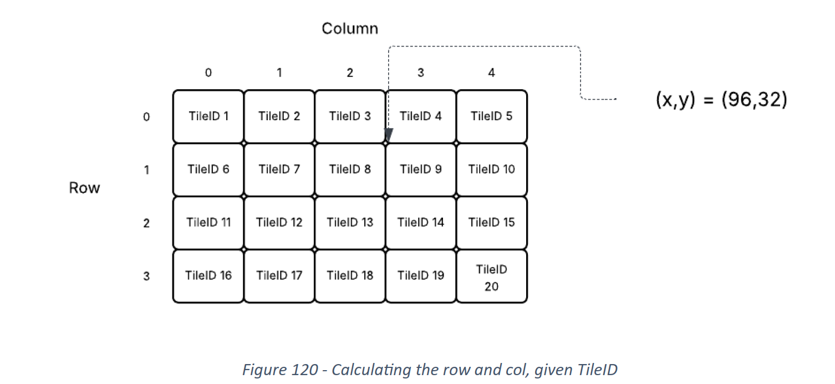

The above is an example of a diagram I created. I use a nice tool called LucidCharts (<https://www.lucidchart.com/>) which is a online diagramming tool. As you can see this is Figure 120 – I have a lot of figures. The document/notes also contains many animated gifs that I create using the application ScreenToGif. Here is an example:



Because the original Microsoft Word started to get huge due to the animated gifs it contained, I had to split my notes into a part 1 and part 2. Hopefully, I will not need a part 3.

While I am following this tutorial I am taking two Pikuma courses (see details below).

### What is a good style for C++ development?

I may be rusty in C++ development but the programming style used in this series feels off to me. I decided to use K&R formatting for my source but then switched over to Java formatting in Code::Blocks since it is used in Pikuma 2D course.. I wish more people would start a series discussing:

* Formatting preferences
* C++ code style preferences
* Testing infrastructure they will use (or not use)
* A review of the main features of the IDE they select

I was not sure of the style of some classes that implemented everything in the header (*.h) file.

|  |
| --- |
| Copilot question: Is it common the create C++ header files that does not use an implement file but implements everything in the header file?  Yes, it's fairly common in C++ to have **header-only implementations**, where all function definitions are written directly in the header file instead of a separate .cpp file. This approach is often used for:  **Common Use Cases**   * **Template Libraries**: Since templates must be instantiated at compile time, their definitions need to be available in the header file. * **Inline Functions**: Functions defined inside a class in a header file are implicitly **inline**, which can improve performance. * **Header-Only Libraries**: Some libraries (like Boost and Eigen) are designed to be **header-only**, simplifying distribution and avoiding linking issues.   **Pros & Cons**  ✅ **Advantages**:   * Easier to distribute (no need for compiled binaries). * Reduces linking complexity. * Improves performance for small functions via inlining.   ❌ **Disadvantages**:   * Can **increase compilation time** since every source file that includes the header must compile the function. * May lead to **larger binary sizes** due to redundant function definitions across translation units. |

I also am reading the Google C++ Style Guide - <https://google.github.io/styleguide/cppguide.html>. It confirms my intuition that the C++ style used in the video tutorial (How to Make a 2D Game Engine with C++ & SDL2) is unconventional. To be honest, I thought it was just dreadfully unconventional and inconsistent. This is why I believe any course or tutorial should cover the style guide they are using. I may not like it but I can understand it.

## A Crash Course in C++

***Progress:*** 5% completed

As part of the effort to learn modern C++ I am reading the book ***C++ Crash Course***, by Josh Lospinoso. The book is a ***No Starch Press*** (<https://nostarch.com/>) book. I purchased the book. Before I purchase any book, I try to check out the reviews on amazon.com.

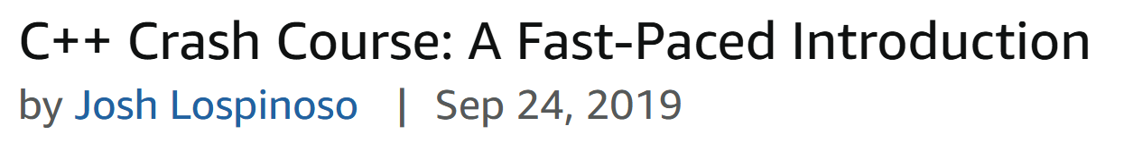

Some publishers are known to produce high quality books, and No Starch Press is one such publisher[6].

I admit I pick up a lot of books for free on pdfdrive.com but I like to pay for books I find useful it supports authors spending their time and energy providing high quality books. This book is perfect for programmers like me who are not familiar with modern C++, it is written of intermediate or advanced programmers in other programming languages.

The code and errata for the book can be found at <https://ccc.codes/>.

TBD…

## Pikuma Courses

I found a website that offers at a reasonable price excellent courses to learn game programming - <https://pikuma.com/>. I am working my way through two courses:

* 2D Game Engine with C++ and Lua
* 2D Game Physics Engine Programming

The course lecturer Gustavo Pezzi explains everything clearly and completely. I never feel the need to go and look up some terminology or tool. You can always post queries for each lecture and know that someone will get back a response in short order.

### 2D Game Engine with C++ and Lua

***Progress:*** 11% completed

This is a perfect companion to the youtube video “How to Make a 2D Game Engine with C++ & SDL2”.



This course is a gentle and comprehensive introduction to the fundamentals of 2D game engine architecture. This course uses the same tools and libraries with the addition of GLM (math helper library), Dear UmGui (to create UI), Sol (a binding library for modern C++ and Lua), and of course Lua (a scripting language).

All the tools are cross-platform. The idea of building cross-platform applications has always intrigued me. I haven’t had to deal with the issues around cross-platform for 20 years because I have been a Java developer. I was able to compile on my Windows desktop my Java code into .class files that I then could upload to the target Linux machine, and it would run with no issues.

I highly recommend the course.

#### Setup

I was planning on working in WSL on Windows but it was reported that the game will have some issues running. I decided to use Code::Blocks for this course. I did follow the instructions on WSL Ubuntu version as far as I could and switched over to Code::Blocks on Windows. I got a bit confused on how to set up lua.

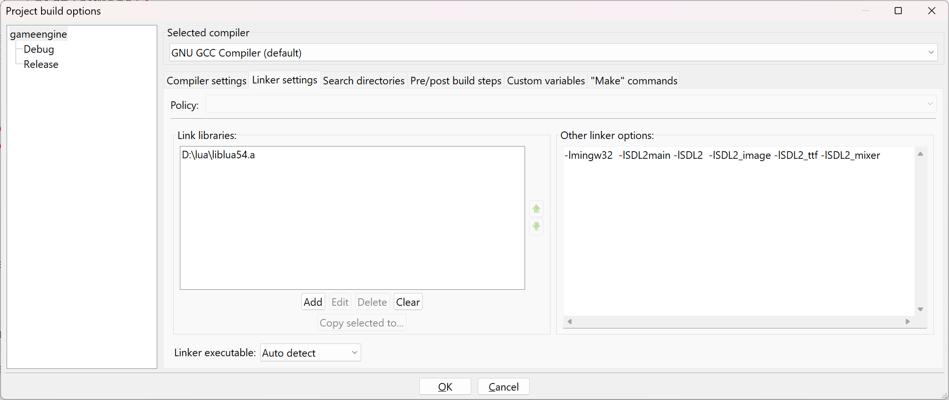

I was trying to insert a linker option for lua but it never worked. I finally figured out that I had to add the link library to the project and things worked!

The course spends a great deal of time showing and explaining how to set up the projects on Windows, Linux and MacOS system. In addition, the course provides a zip file with all the library files and assets!

# The Ugly Truth About YouTube Tutorials

Few of the youtube tutorials featuring a topic are done by professional presenters or instructors. I occasionally get the feeling that the video creator just learned the material themselves or at least needs to put in more time on the topic of teaching and less on showing off their skill and knowledge. I guess you get what you pay for.

The most notable thing is that many of the courses are dated and old, in addition, it would appear the video channel owner no longer uploads any new videos. This means that any comments or corrections will probably go unread. Since I am learning how to create game programs many of the videos I encounter on youtube fall into the category of – not well done.

I have been disappointed with almost all youtube video tutorials that involved coding something up. There are many good youtube channels that discuss specific topics related to programming but I should note that they are highly opinionated and may not be correct or fit your style.

## Other Places to Learn

I have taken the Coursera course “Game Development: HTML to Unreal Engine Mastery”. It was a terrible course. It should have been “getting a quick taste but you will learn nothing.” The title promised too much when it was not designed to deliver mastery in any area of instruction. I don’t see Coursera as a place to learn game development.

A popular place for reasonably priced courses is Udemy. Again, you get what you pay for. It is hard to find decent courses since they flood every topic with so many courses and varying levels of talent in the instruction. The quality of many of the courses tends to be low. I would try to find honest reviews before paying for a course. There are some rather decent courses that will be listed in the Appendix.

The best online instruction I have found for game development is the Pikuma website. The video creator is in fact an instructor at the university level – and it shows.

# Websites to Visit

* <https://lazyfoo.net/tutorials/SDL/index.php>
* <https://wiki.libsdl.org/SDL2/FrontPage>
* <https://wiki.libsdl.org/SDL2_image>
* <https://www.ferzkopp.net/wordpress/2016/01/02/sdl_gfx-sdl2_gfx/>
* <https://www.freepik.com/>
* <http://programarcadegames.com/>
* <https://giphy.com/>
* <https://github.com/nsklaus/SoftEngine>
* <https://forum.gdevelop.io/t/solved-how-do-i-slice-a-sprite-sheet/37755>
* <https://box2d.org/>
* <https://www.gameart2d.com/> - Tile sets

Atari 2600

Grand Prix (top-down view)

Indy 500

Night Driver

Pole Position

Fatal Run

Enduro

1. I am starting this journey in 2025
2. I have a patent from a C program I built with working for AT&T as a graduate student (see: <https://patents.justia.com/inventor/lorraine-figueroa>)
3. I will never be able to create anything close to a modern racing game, but I can still demonstrate how to use a tool like Unity or Unreal Engine to build a better looking modern car racing game.
4. Games made with Unreal Engine - https://www.pcgamingwiki.com/wiki/List_of_games_that_use_Unreal_Engine_5
5. All my notes and projects are available on my nyguerrillagirl github site. I am currently using the repo 300-days-of-code, as I progress the repo name may change.
6. Another publisher I am careful about is PacktPub. It has a reputation for selling dreadful books. It feels like they find the first person who claims to know topic X and then it shamefully publishes a book by authors who barely know the topic.